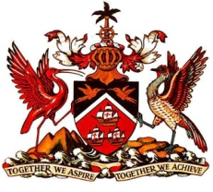

PERMANENT MISSION OF THE REPUBLIC OF TRINIDAD AND TOBAGO
TO THE OFFICE OF THE UNITED NATIONS, GENEVA

Statement at the Universal Periodic Review (UPR) of Saint Vincent and the Grenadines, Palais des Nations, Geneva, 2nd May 2016

Thank you Mr. President.

Trinidad and Tobago notes the continued commitment of Saint Vincent and the Grenadines to the improvement of the quality of life for its citizens as exemplified by the formation of the National Economic and Social Development Plan (2013-2025).

Amidst the various financial and human resource challenges commonly faced by small states, Trinidad and Tobago congratulates our fellow CARICOM state for having halved the number of hungry and undernourished people between 1992 and 2012; for its efforts to strengthen its institutional and legal framework to address domestic violence through the Domestic Violence Act of 2015; as well as for steps taken to provide housing for the vulnerable under the “Lives to live” Programme.

My delegation welcomes the necessary measures which are being put in train to complete and submit outstanding reports in connection with various human rights obligations, and further applauds the engagement in the work of the Human Rights Council though the participation in the Voluntary Technical Assistance Fund to Support the Participation of Least Developed Countries and Small Island Developing States.

My delegation recommends that Saint Vincent and the Grenadines seek assistance, as appropriate, to support ongoing efforts to preserve its tangible and intangible cultural heritage.

Trinidad and Tobago extends its very best wishes to our Caribbean neighbour for a successful review.

I thank you Mr. President.

